**EPT. OF ELECTRICAL & ELECTRONICS ENGINEERING SRM INSTITUTE OF SCIENCE AND TECHNOLOGY, Kattankulathur – 603203.**

|  |
| --- |
| **Title of Experiment : Displacement measurement using LVDT and**  **Date: 29.01.2021 pressure measurement using Strain gauge** |
| **Name of the candidate : Debarghya Barik**    **Register Number : RA2011026010022**    **Date of Experiment : 27.01.2021** |
|  |

|  |  |  |  |
| --- | --- | --- | --- |
| Sl.  No. | Marks Split up | Maximum marks  (50) | Marks obtained |
| 1 | Pre Lab questions | 5 |  |
| 2 | Preparation of observation | 15 |  |
| 3 | Execution of experiment | 15 |  |
| 4 | Calculation / Evaluation of Result | 10 |  |
| 5 | Post Lab questions | 5 |  |
|  | **Total** | **50** |  |

**Staff Signature**

|  |  |
| --- | --- |
| **Experiment No. 9 a) Date :** | **Displacement measurement using Linear Variable**  **Differential Transformer** |

**Aim**: To measure the displacement and to determine the characteristics of LVDT (Linear Variable Differential Transformer).

**Apparatus required**: LVDT, Digital displacement indicator, Calibration jig (with micrometre).

**Online Link:**

h[ttps://sl-](ttps://sl-coep.vlabs.ac.in/List%20of%20experiments.html?domain=Electrical%20Engineering)

[coep.vlabs.ac.in/List%20of%20experiments.html?domain=Electrical%20Engineering](ttps://sl-coep.vlabs.ac.in/List%20of%20experiments.html?domain=Electrical%20Engineering)

**THEORY: LVDT (LINEAR VARIABLE DIFFERENTIAL TRANSFORMER)**

The most widely used inductive transducer to translate the linear motion into electrical signals is the linear variable differential transformer (LVDT). The basic construction of LVDT is shown in Figure 1.

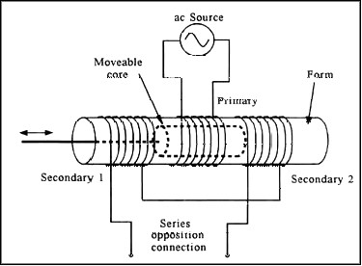

Figure 1. Linear Variable Differential Transformer

The transformer consists of a single primary P and two secondary windings S1 and S2 wound on a cylindrical former. The secondary windings have equal number of turns and are identically placed on either side. A moveable soft iron core is placed inside the transformer. The displacement to be measured is applied to the arm attached to the soft iron core. In practice the arm is made of highly permeability, nickel iron which is hydrogen annealed. This gives low harmonics low null voltage and high sensitivity. This is slotted longitudinally to reduce eddy current losses. The assembly is placed in stainless steel housing and the end leads provides electrostatic and electromagnetic shielding. The frequency of AC applied to primary windings may be between 50 Hz to 20 kHz. Since the primary winding is excited by an alternating source, it produces an alternating magnetic field which in turn induces alternating current voltage in the two secondary windings. Figure 2 depicts a cross-sectional view of an LVDT. The core causes the magnetic field generated by the primary winding to be coupled to the secondary. When the core is centred perfectly between both secondary and the primary as shown, the voltage induced in each secondary is equal in amplitude and 180 degree out of phase. Thus the LVDT output (for the series-opposed connection shown in this case) is zero because the voltage cancels each other. E0 = Es1 - Es2 = 0.

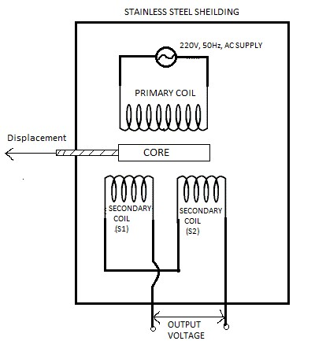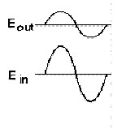

Figure 2. View of LVDT Core and Windings

Displacing the core to the left causes the first secondary to be more strongly coupled to the primary than the second secondary. The resulting higher voltage of the first secondary in relation to the second secondary causes an output voltage that is in phase with the primary voltage. Likewise, displacing the core to the right causes the second secondary to be more strongly coupled to the primary than the first secondary. The greater voltage of the second secondary causes an output voltage to be out of phase with the primary voltage.

**Procedure**:

1. Plug power chord to AC mains 230 V, 50 Hz and switch on the instrument.
2. Place the READ/CAL switch at READ position.
3. Balance the amplifier with the help of zero knob so that display should read zero without connecting the LVDT to instrument.
4. Replace the READ/CAL switch at CAL position.
5. Adjust the calibration point by rotating CAL knob so display should read 10.00

i.e., maximum calibration range.

1. Again keep the READ/CAL switch at READ position and connect the LVDT cable to instrument.
2. Make mechanical zero by rotating the micrometre. Display will read (00.00) this is null balancing.
3. Give displacement with micrometre and observe the digital readings.
4. Plot the graph of micrometre reading v/s digital reading.

**Model Graph:**

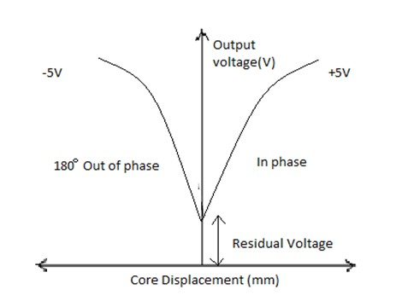

**Stimulation Diagram:**

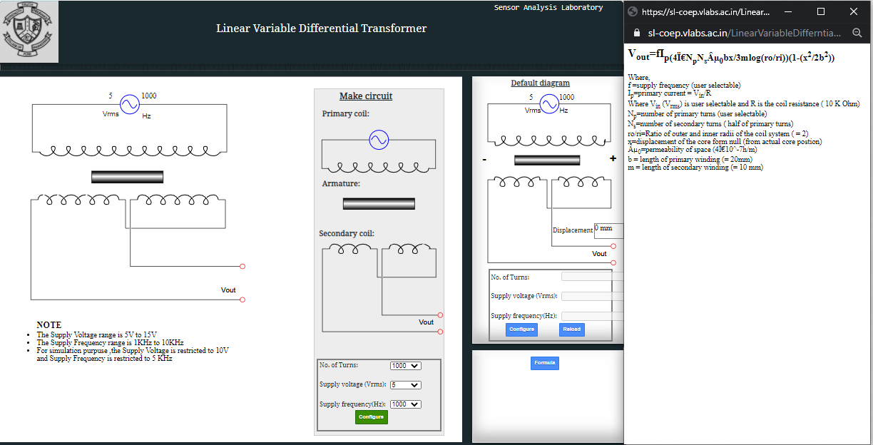

**Simulation**

**Graph**

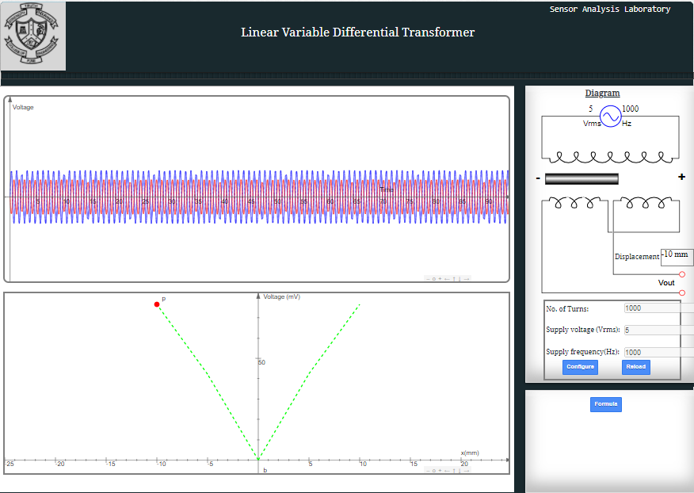

**Tabulations:**

**No. of Turns : 1000**

**Supply voltage (Vrms) : 5**

**Supply frequency (Hz) : 1000**

|  |  |  |  |
| --- | --- | --- | --- |
| **SL No:** | **MICROMETER**  **DISPLACEMENT (mm)** | **CORE DISPLACEMENT (mm)** | **SECONDARY OUTPUT VOLTAGE (mV)** |
| **1** | **8** | **- 8** | **64.29** |
| **2** | **6** | **- 6** | **50.05** |
| **3** | **4** | **- 4** | **34.24** |
| **4** | **2** | **- 2** | **17.38** |
| **5** | **1** | **- 1** | **8.72** |
| **6** | **1** | **1** | **8.72** |
| **7** | **2** | **2** | **17.38** |
| **8** | **4** | **4** | **34.24** |
| **9** | **6** | **6** | **50.05** |
| **10** | **8** | **8** | **64.29** |

**Graph:**

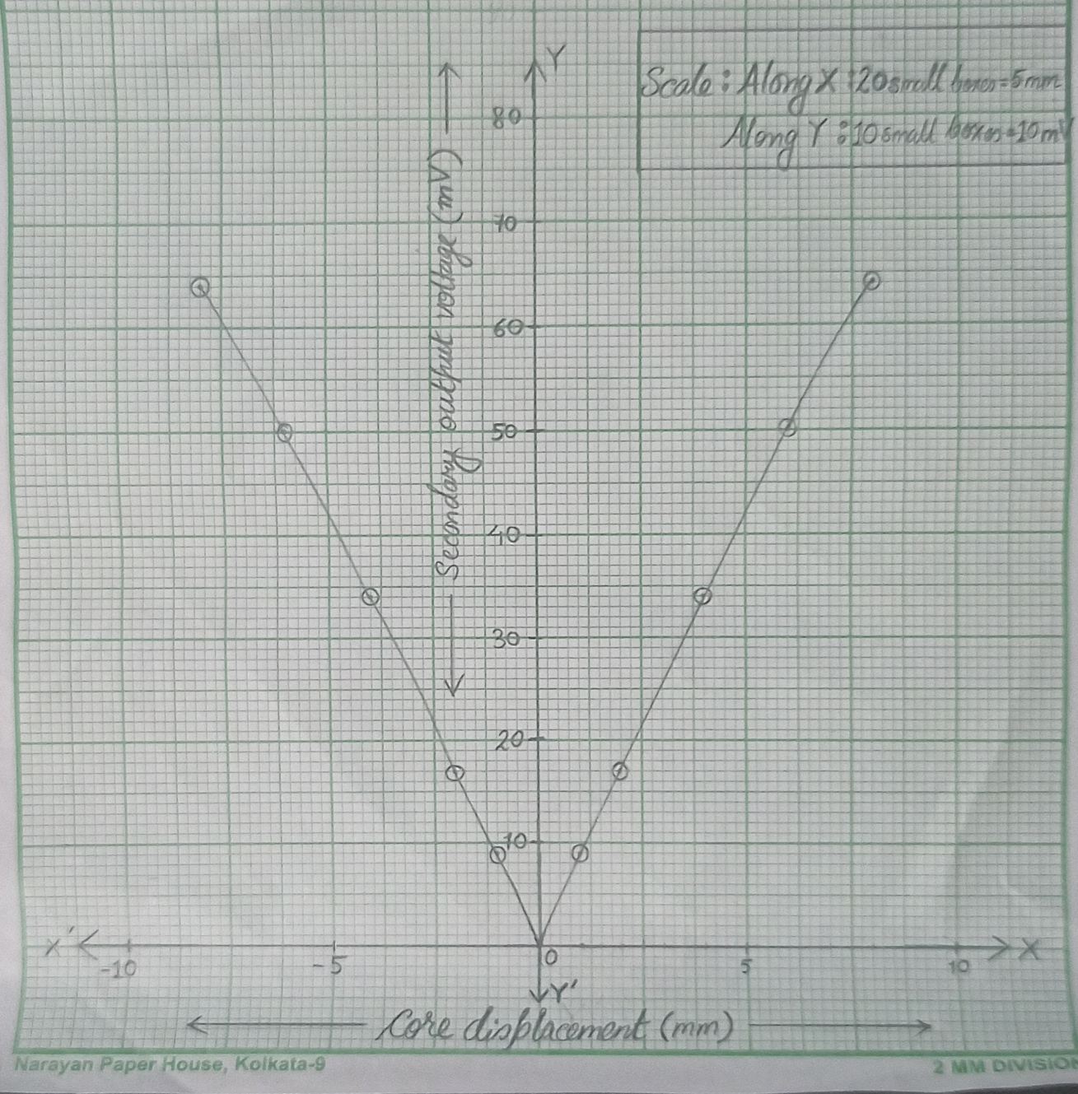

**Result:** Hence, with the above tabulation and the graph, the displacement and the characteristics of LVDT (Linear Variable Differential Transformer) are determined.

**POST LAB QUESTIONS:**

1. **What are the three principles of Inductive transducers?**

**Ans:** The inductive transducer uses three working principles which include the following.

* + Self-Inductance Change.
  + Mutual Inductance Change.
  + Eddy Current Production.

1. **What are the limitations of LVDT?**

**Ans:** The limitations of LVDT are:

* Large displacements are required for appreciable differential output.
* They are sensitive to stray magnetic fields.
* Dynamic response is limited.
* Temperature also affects the transducer.

1. **Where LVDT is used?**

**Ans: LVDTs** have been widely **used** in applications such as power turbines, hydraulics, automation, aircraft, satellites, nuclear reactors, and many others. These transducers have low hysteresis and excellent repeatability.

1. **What are the different types of transducers used for displacement measurement?**

**Ans: Different types of transducers used for displacement measurement are:**

1. Linear Potentiometer Transducer.
2. Linear Motion Variable Inductance Transducer.
3. Proximity Inductance Transducer.
4. Capacitive Transducer.
5. Linear Voltage Differential Transformer (LVDT)

1. **What is the difference between variable resistance & variable inductance displacement transducer?**

**Ans:** The variable resistance transducer work on the principle that the resistance of the conductor is directly proportional to the length of the conductor and inversely proportional to the area of the conductor.

Whereas, the inductive transducers work on the principle of the electromagnetic induction. A number of factors, the induction of the magnetic material depends on are the number of turns of the coil on the material, the size of the magnetic material, and the permeability of the flux path.

---------------------------------------------------------X-------------------------------------------------

|  |  |
| --- | --- |
| **Experiment No. 9 b) Date : 27.01.2021** | **Strain measurement using Strain gauge** |
| **Name of the candidate : Debarghya Barik**    **Register Number : RA2011026010022**    **Date of Experiment : 27.01.2021** | |

**Aim**: To measure the strain using strain gauge.

**Apparatus Required**: Strain gauge, weight, LABVIEW software.

**Theory**: Strain is the amount of deformation of a body due to an applied force. More specifically, strain (e) is defined as the fractional change in length, Strain can be positive (tensile) or negative (compressive). Although dimensionless, strain is sometimes expressed in units such as in./in. or mm/mm. In practice, the magnitude of measured strain is very small. Therefore, strain is often expressed as microstrain (me), which is e x 10-6. When a bar is strained with a uniaxial force, as in Figure 1, a phenomenon known as Poisson Strain causes the girth of the bar, D, to contract in the transverse, or perpendicular, direction. The magnitude of this transverse contraction is a material property indicated by its Poisson's Ratio. The Poisson's Ratio n of a material is defined as the negative ratio of the strain in the transverse direction (perpendicular to the force) to the strain in the axial direction (parallel to the force), or n = eT/e. The most widely used gage is the bonded metallic strain gage. The metallic strain gauge consists of a very fine wire or, more commonly, metallic foil arranged in a grid pattern. The grid pattern maximizes the amount of metallic wire or foil subject to strain in the parallel direction (Figure 2). The cross-sectional area of the grid is minimized to reduce the effect of shear strain and Poisson Strain. The grid is bonded to a thin backing, called the carrier, which is attached directly to the test specimen.

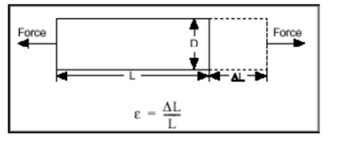

# Figure 1. Strain measurement

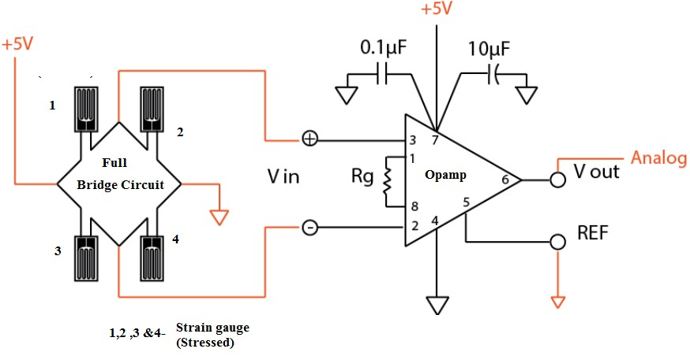

# Figure 2. Full- Bridge Strain gauge circuit

**Procedure**:

1. Connect the cantilever strain measurement assembly to the main trainer and switch ON the trainer
2. Connect the multi meter at the Instrument output with multimeter in DC VOLTAGE mode and 20 V Range.
3. Connect this STRAIN output also to display section marked Vout.
4. Now without any strain or load in the cantilever beam. So adjust the OFFSET CONTROL to 0 volts at the output.
5. Now place 500 grams weights on the pan suspended n the beam and adjust the gain or call control to read 0.5 volt by multimeter at the strain output terminal.
6. Now remove the weight from the pan and the output must be 0 volt. IF not then readjust OFFSET Control
7. Table the readings for different weight or strain on the load cell as well as display readings.

**PRE LAB QUESTIONS (Strain gauge):**

1. **How does a strain gauges work?**

**Ans:** Strain is the deformation or displacement of material that results from an applied stress. Stress is the force applied to a material, divided by the material’s cross-sectional area. A strain gauge is a sensor whose measured electrical resistance varies with changes in strain. Strain gauges convert the applied force, pressure, torque, etc., into an electrical signal which can be measured.

1. **What is piezo-resistive effect?**

**Ans:** The piezo-resistive effect describes the change in electrical resistance that occurs when an external force is applied to a semiconductor. This change only affects the material's electrical resistivity. Unlike the [piezoelectric effect,](https://www.comsol.co.in/multiphysics/piezoelectric-effect) it cannot be used to generate a voltage across the device.

1. **What are the types of strain gauge?**

**Ans:** The different types of strain gauge are

* Linear strain gauges
* Membrane Rosette strain gauges
* Double linear strain gauges
* Full bridge strain gauges
* Shear strain gauges.

1. **Define gauge factor**

**Ans:** Gauge Factor is defined as the ratio of per unit change in resistance to the per unit change in length.

1. **Mention some practical applications of strain gauge**

**Ans:** Strain gauges are used to measure the torque applied by a motor, turbine, or engine to fans, generators, wheels, or propellers. This equipment is found in power plants, ships, refineries, automobiles and industry at large.

**Circuit Diagram:**

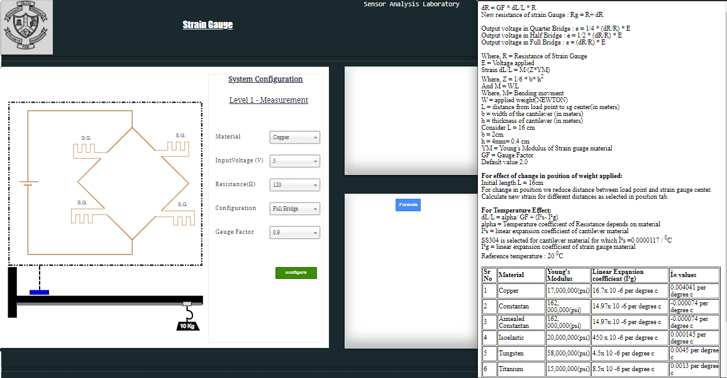

**Tabulation:**

**Material : Copper**

**Input Voltage (V) : 5**

**Resistance (Ohm) : 120**

**Configuration : Full Bridge**

**Gauge Factor : 0.9**

|  |  |  |  |
| --- | --- | --- | --- |
| **S.no** | **Weight in Pan**  **(Grams)** | **Value of gauge resistance Rg (ohm)** | **Output Voltage**  **(mV)** |
| **1** | **0.5** | **120.0136** | **0.567** |
| **2** | **1.0** | **120.0271** | **1.129** |
| **3** | **2.0** | **120.0542** | **2.258** |
| **4** | **3.0** | **120.0814** | **3.391** |
| **5** | **4.0** | **120.1085** | **4.521** |
| **6** | **5.0** | **120.1356** | **5.650** |
| **7** | **6.0** | **120.1627** | **6.779** |
| **8** | **7.0** | **120.1898** | **7.908** |
| **9** | **8.0** | **120.2169** | **9.037** |
| **10** | **9.0** | **120.2441** | **10.171** |

**Calculations:**

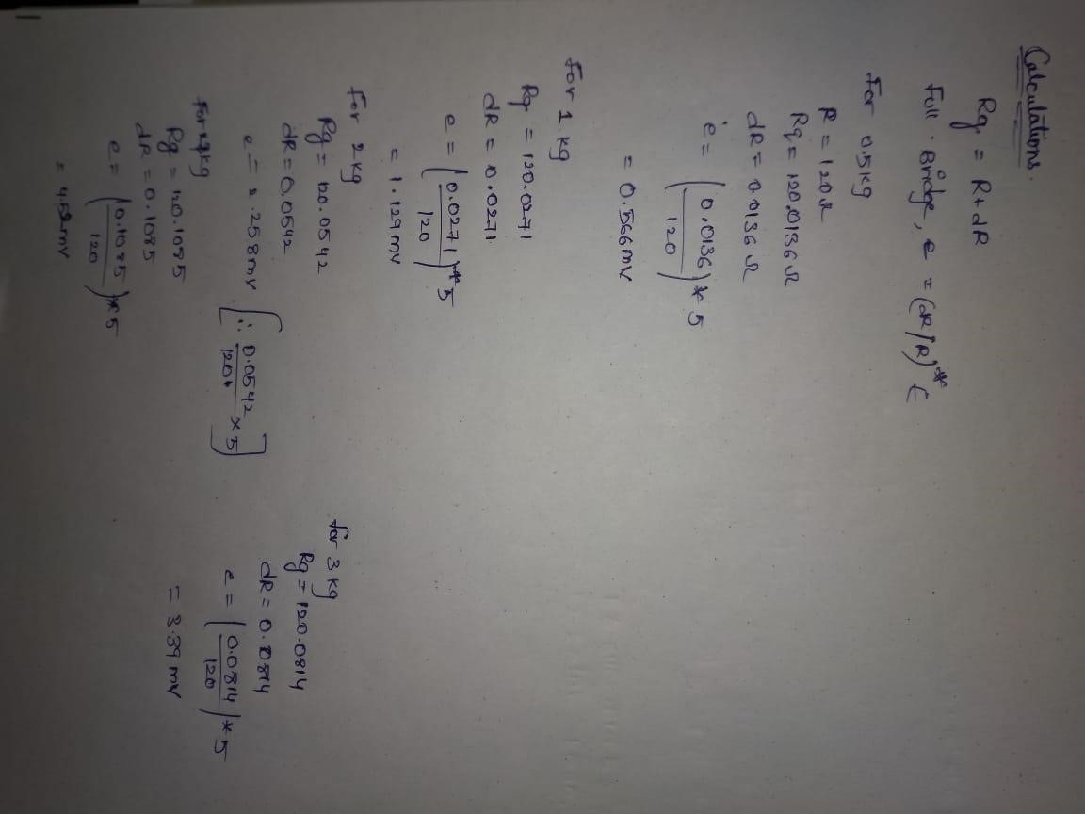

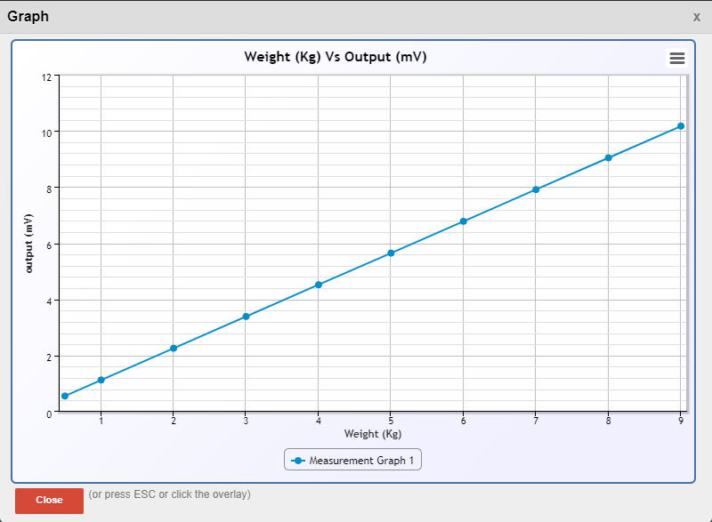

**Result:** Hence, using Strain gauge the above data are calculated.

**POST-LAB QUESTIONS:**

1. **How can you apply the principle of stain gauge?**

Ans:  A **strain gauge** works on the **principle** of electrical conductance. It is a resistor used to measure strain on an object when an external force is applied on an object, due to which there is a deformation occurring in the shape of the object. This deformation in the shape is both compressive or tensile is called strain, and it is measured by the strain gauge. As a result of it, there is a change in [resistance e](https://www.electrical4u.com/electrical-resistance-and-laws-of-resistance/)nd-to-end.

1. **What is meant by passive transducer?**

Ans: The **passive transducer means** the **transducer** whose internal parameters like capacitance, resistance & inductance changes because of the input signal. Strain gauges, capacitive **transducer**, thermistors are **examples of passive transducer**. Its output form relies upon on variant in **passive** associated.

1. **What is sensitivity of strain gauge?**

**Ans:** A fundamental parameter of the **strain gage** is its **sensitivity** to **strain**, expressed quantitatively as the **gage** factor (GF). GF is the ratio of the fractional change in electrical resistance to the fractional change in length, or **strain**: The GF for metallic **strain gages** is usually around 2.

1. **What is a microstrain?**

**Ans:** Usually, strain is in the order of um/m, i.e 10-6, and therefore, the unit ‘µε’ (macrostrain) is most commonly used.

1. **What are the limitations of a strain gauge?**

**Ans:** Each strain gauge has its limitations in terms of **temperature**, **fatigue**, the **amount** of strain, and the measurement environment. strain gauges biggest disadvantage is that they are non-linear. It needs regular calibration in order to use perfectly and take perfect reading.

---------------------------------------------------X------------------------------------------------